ECA5612 - 5G / 6G Communication Systems
CO2-AT2 Simulation Task
17.Simulation of 5G NR air interface performance under different numerologies, bandwidths, latency, subcarrier spacing, and throughput.

Program:
clc; clear; close all;
% Parameters
BW = [20 50 100]; % Bandwidth (MHz)
SCS = [15 30 60 120]; % Subcarrier Spacing (kHz)
mu = [0 1 2 3]; % Numerology
SE = 6; % Spectral Efficiency (bps/Hz)
fprintf('5G NR Performance Simulation\n\n');
fprintf('BW(MHz)\tSCS(kHz)\tLatency(ms)\tThroughput(Mbps)\n');
for b = 1:length(BW)
for s = 1:length(SCS)
% Slot duration (ms)
latency = 1/(2^mu(s));
% Throughput calculation
throughput = BW(b)*1e6*SE/1e6; % Mbps
fprintf('%d\t\t%d\t\t%.3f\t\t%.1f\n', ...
BW(b), SCS(s), latency, throughput);

end
end

Output:
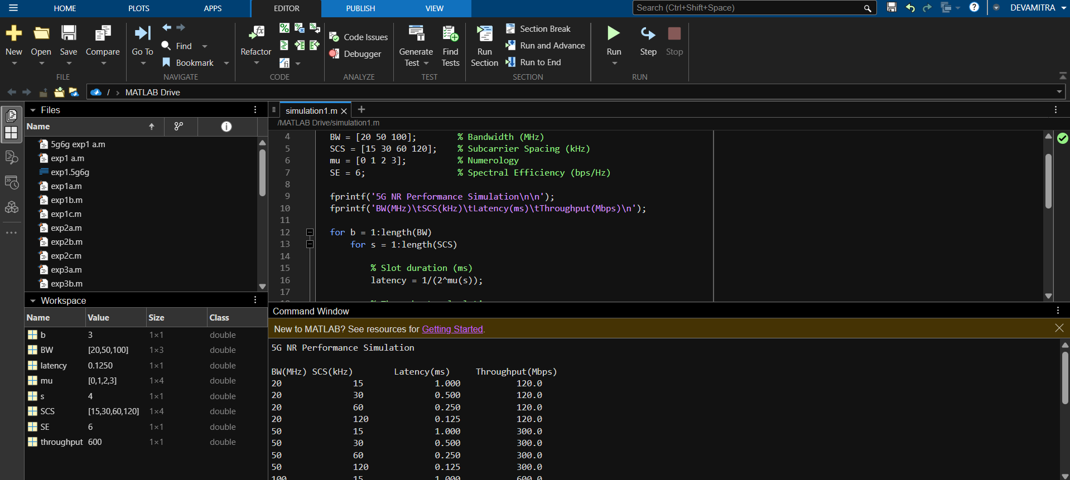

24.Simulation of service-based architecture performance under AMF load, SMF load, UPF throughput, latency, and session count .

Program:
clc; clear; close all;
% Parameters
sessions = [100 500 1000 2000 5000]; % Number of sessions
% Simple performance models
AMF_Load = sessions * 0.02; % CPU Load (%)
SMF_Load = sessions * 0.015; % CPU Load (%)
UPF_Throughput = sessions * 0.5; % Mbps
Latency = 5 + sessions * 0.002; % ms
% Display Results
T = table(sessions', AMF_Load', SMF_Load', ...
UPF_Throughput', Latency', ...
'VariableNames', {'Sessions','AMF_Load_%','SMF_Load_%', ...
'UPF_Throughput_Mbps','Latency_ms'});
disp(T);
% Plot Results
figure;
subplot(2,2,1);
plot(sessions, AMF_Load,'-o','LineWidth',2);
xlabel('Session Count'); ylabel('AMF Load (%)');
title('AMF Load');
subplot(2,2,2);
plot(sessions, SMF_Load,'-s','LineWidth',2);
xlabel('Session Count'); ylabel('SMF Load (%)');
title('SMF Load');
subplot(2,2,3);
plot(sessions, UPF_Throughput,'-^','LineWidth',2);
xlabel('Session Count'); ylabel('Throughput (Mbps)');
title('UPF Throughput');
subplot(2,2,4);
plot(sessions, Latency,'-d','LineWidth',2);
xlabel('Session Count'); ylabel('Latency (ms)');
title('Latency');

Output:
